Accessibility Guide for Museum Collection Centre
MuseumCollectionsCentre@edinburgh.gov.uk, +44 (0) 131 556 9536, https://www.edinburghmuseums.org.uk/venue/museum-collection-centre
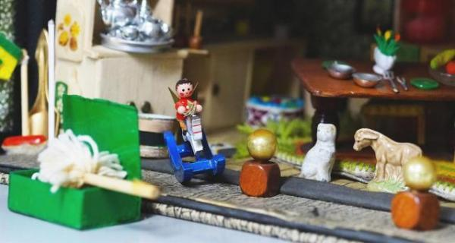

Welcome
The Museums Collection Centre is an amazing treasure trove of objects spanning a wide range of subjects. Visitors taking one of our tours can view a huge array of objects not currently on display at the Museums of Edinburgh, Childhood and the People’s Story. Many are classified as Social History; these include tools and technology from local industries such as printing or brewing; familiar domestic objects from granny’s kitchen and parlour; shop signs and billboards which were part of everyday community life; as well as more decorative Scottish pottery and glass.

At a Glance

Level Access
- The main entrance has level access with a ramp. The ramp is permanent.
- There is level access from the main entrance to:
  - Ground floor
  - Accessible toilets

Access with steps
- There are steps from the main entrance to:
  - First floor

General
- There is at least 1 public toilet for disabled visitors.

Getting here
10 Broughton Market
Edinburgh
EH3 6NU

Travel by public transport
- You can get to Museum Collection Centre by bus, train and tram.
- From Edinburgh Bus Station (X5; X9; X54; X55; X56; X58; X59; X60), you can access the Museum Collection Centre in 7min via York Lane and Albany Lane. The Museum Collection Centre is the cream painted building at the end, just before the junction with Barony Street. The bus stop is 0.3 miles / 0.5 km from Museum Collection Centre.
- The nearest train station is Waverley Railway Station. The train station is 0.5 miles / 0.8 km from Museum Collection Centre.
- The nearest tram station is York Place. The tram station is 0.2 miles / 0.3 km from Museum Collection Centre.

Travel by taxi
- You can get a taxi with City Cabs by calling 0131 228 1211. The taxi company has a wheelchair accessible vehicle.

Parking
- There is a drop-off point at the main entrance. The drop-off point has a dropped kerb.
- The museum has a drop-off point in front of the entrance. Unfortunately, access is partly blocked by three bollards. However, the museum's area is quiet enough for a car to briefly stop to drop-off passengers 2 meters away from the museum's entrance.
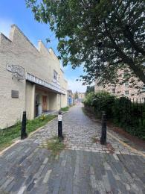
View of the bollards blocking the entrance.

Arrival

Path to main entrance
- From the street to the main entrance, there is level access.
- The path is 2000mm wide, or more.

Main entrance
- The main entrance has level access.
- There is a permanent ramp.
- The door is 1400mm wide.
- The main door is side hung and manual.
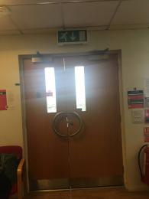
Museum's entrance door from inside
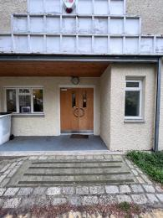
Ramp and Entrance to the Museum Collection Centre

Getting around inside

Visual Impairment - General Information
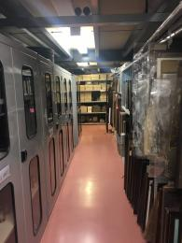
inside the building

Ground floor
- From the main entrance to this area, there is level access. There is a permanent ramp. The route is 1500mm wide, or more. The door is 800mm wide.
- Some display information is low, for wheelchair users. There are seats.
- The Museum Collection Centre offers pre-arranged visits that can be booked via + 44 (0) 131 556 9536. Tours of the Collection Centre are very adaptable to visitor needs. In the case of special requirements (as wheelchair accessibility), please explain your needs/ situation to the staff so that they can prepare everything in advance of your visit.
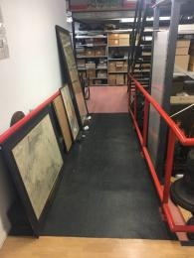
Ramp to the ground floor
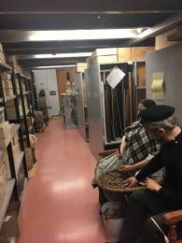
Ground floor

Public toilet

Accessible toilets
- There is a public toilet for disabled visitors.
- From the main entrance to the public toilet, there is level access.

First floor
- From the main entrance to this area, there are 15 steps. There is no lift and no ramp.
- The second floor of the storage space is only accessible via stairs. However, the objects usually shown upstairs can be brought to you on the ground floor.
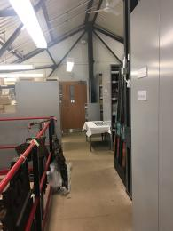
First floor

Customer care support

Accessibility equipment
- The museum is located a short distance from St Andrews Square ( 0.4 miles) and Queens Street (0.4 miles) Gardens.
- We have other services for people with accessibility requirements.
- Our tours are adaptable to various access needs. Please alert staff of your needs when booking tours and we will do our best to meet them.

Guide last updated: 25 July 2023

