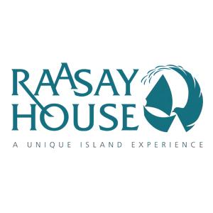

Accessibility Guide for Raasay House
info@raasay-house.co.uk, 01478660300, https://www.raasay-house.co.uk
Contact for accessibility enquiries: Carol Anderson
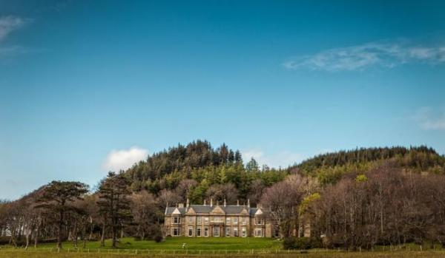

Welcome
Enjoy adventure, fun, wildlife and tranquility on one of Scotland's most beautiful and unspoilt islands. Raasay House is situated on the beautiful inner hebridean island of Raasay which lies between the Isle of Skye and the Scottish mainland. This small island location feels magically remote yet is actually very accessible. The short ferry journey from Skye takes only 20 minutes and Inverness airport is just two and a half hours away by road.
Raasay House Provides: *Accommodation from Budget to Deluxe, Outdoor Activities, Bistro, Resturant, Bar*
Watch the video: Time lapse view from Raasay House

At a Glance

Level Access
- The main entrance has 2 steps. There is no lift and no ramp.
- There is level access from the main entrance to:
  - Dining Table
  - The Grounds

Access with steps
- There are steps from the main entrance to:
  - Reception
  - Bedroom
  - Restaurant
  - Bistro
  - Library
  - Bar
  - Disabled Toilet
  - Games Room
  - The Patio

Visual
- Some parts of the venue have low lighting.

General
- There is at least 1 public toilet for disabled visitors.
- Staff are available 24 hours a day.
- We have emergency evacuation procedures for disabled visitors.

Getting here
Raasay Outdoor Centre Ltd
Raasay House
Isle of Raasay
By Kyle
IV408PB

Travel by public transport
- You can get to Raasay House by boat or ferry.
- The nearest port is Sconser. The port is 1 miles / 1.6 km from Raasay House.
- There is no public transport on the island.

Travel by taxi
- We have a transfer service for visitors. Our mini bus is not wheelchair compatible.

Parking
- We have a car park. There are accessible parking spaces. The parking is less than 50 metres from the main entrance. Parking is free.
- There is a drop-off point at the main entrance. The drop-off point has a dropped kerb.
- From the parking to the main entrance, there are 2 steps. There is no ramp and no lift.
- Watch the video: Raasay House Morning Spring Time lapse Video
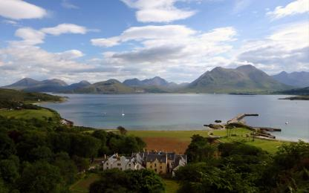
Raasay House from above
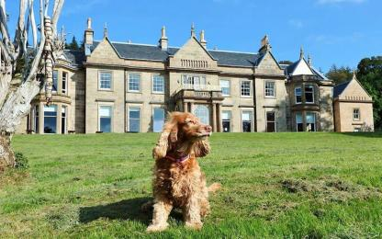
Raasay House is dog friendly.
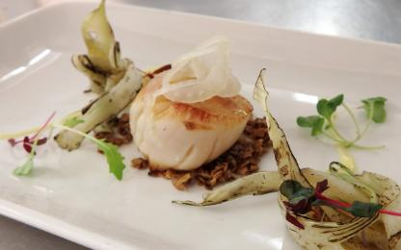
Local scallop starter dish
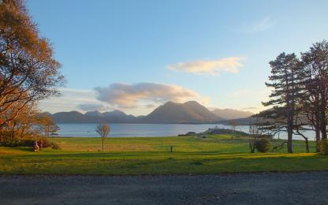
The view from the house
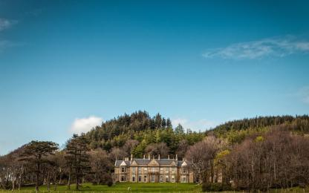
Raasay House from the ferry

Arrival

Path to main entrance
- From the street to the main entrance, there are 2 steps. There is no ramp and no lift.
- The path is sloped.

Main entrance
- The door is 1000mm wide.
- The main entrance has 2 steps.
- The main door is side hung and manual.
- The other entrance door is 1000.00mm wide.
- There are 2 entrances on the flat. There is one right next to the disabled parking space which has a ramp at it. It opens into our restaurant. 2nd one drive past the front o the house and take a right, park and go under the archway then right.

Getting around inside

Visual Impairment - General Information
- Some parts of the venue have low lighting.

Reception
- From the main entrance to reception, there are 2 steps. There is no lift and no ramp.
- The check-in desk has a low section for wheelchair users. You can sit down at reception.

Bedrooms
- All bedrooms have windows.
- Bedrooms have ceiling lights, bedside lamps and desk or table lamps.
- Lights are LED and energy saving. All bedrooms are non-smoking.
- Some bedrooms have fitted carpets.
- The bedroom nearest the main entrance has 25 steps.
- We have bathrooms with a bath and overhead shower.

Lounge

Library
- From the main entrance to the lounge, there are 2 steps. There is no lift and no ramp.
- You can come in a door to the rear of the building which is on the flat.

Bar

Bar
- From the main entrance to the bar, there are 2 steps. There is no lift and no ramp.
- You can come in a door to the rear of the building which is on the flat.

Public toilet

Disabled Toilet
- There is a public toilet for disabled visitors.
- From the main entrance to the public toilet, there are 2 steps. There is no lift and no ramp.
- You can come in a door to the rear of the building which is on the flat.

Place to eat and drink

Restaurant
- From the main entrance to the dining area, there are 2 steps. There is no lift and no ramp.
- To get to a table, there are no steps.
- There is background music.
- We cater for vegetarian, gluten free (celiacs), lactose free (dairy free), nut free and vegan specific diets.

Place to eat and drink

Bistro
- From the main entrance to the dining area, there are 2 steps. There is no lift and no ramp.
- To get to a table, there are no steps.
- There is background music.
- We cater for vegetarian, gluten free (celiacs), lactose free (dairy free), nut free and vegan specific diets.

Games Room
- From the main entrance to this area, there are 25 steps. There is no lift and no ramp.

Getting around outside

The Grounds
- From the main entrance to the gardens, there is level access.

Terrace

The Patio
- To get to a table, there are no steps.
- From the main entrance to the terrace, there are 2 steps.

Customer care support

Accessibility equipment
- The nearest toilet area for assistance dogs is located within the grounds, 2 metres from the main entrance.

Customer care support
- Staff are available 24 hours a day.

Guide last updated: 16 August 2023

